ASSESSMENT TOOL 3
Coding Challenge Questions
Computer Architecture (CSA12)
- YAVANIKA S 192521258

Table of Contents
- Question 1 - CPU Instruction Cycle Simulator
- Question 2 - Bus Architecture Simulator (Single / Multi / Hierarchical)
- Question 3 - CPU Benchmarking Tool
- Question 4 - 8085/8086 Addressing Mode Simulator
- Question 5 - Number System Converter & Mini Assembler/Disassembler

Question 1
Design and implement a CPU simulator that executes a set of basic instructions (LOAD, STORE, ADD, SUB, MOV, JMP) by simulating the instruction fetch, decode, execute, memory access, and write-back stages. Display the register and memory contents after each stage in instruction execution and calculate the total execution cycles.
Concept
A CPU executes every instruction in a fixed sequence of stages, known as the instruction cycle: Fetch (get the instruction from memory), Decode (identify the operation and operands), Execute (perform the ALU operation), Memory Access (read/write data if needed), and Write Back (store the result in a register). This program models that cycle step-by-step, one instruction at a time, and prints the state of the registers and memory after every stage.
Approach
- Keep a small register dictionary (R0-R3) and a memory list.
- Store the program as a simple list of instruction strings, e.g. 'ADD R2 R0 R1'.
- For every instruction: split the line to get opcode and operands (fetch + decode), run the matching operation (execute), touch memory only for LOAD/STORE, then print the updated registers (write back).
- A cycle counter increases by 1 after every instruction, giving the total execution cycles at the end.

Flowchart
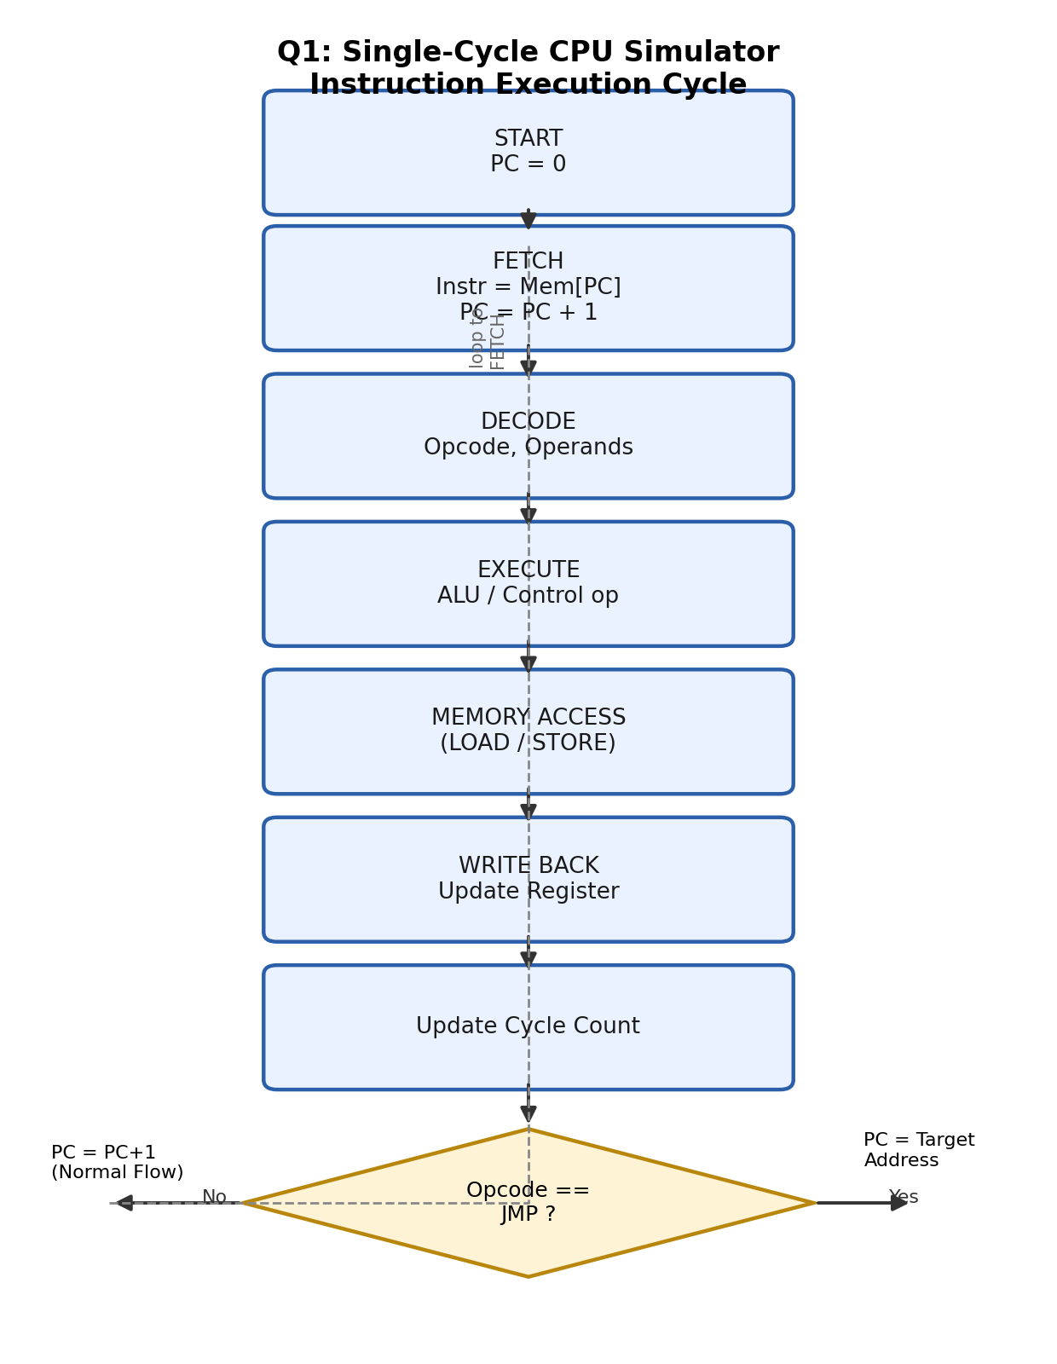

Fig 1.1 - Instruction execution cycle followed by the simulator

Python Implementation
# Q1. Simple CPU Instruction Cycle Simulator
reg = {"R0": 0, "R1": 0, "R2": 0, "R3": 0}
mem = [0] * 10
cycles = 0

program = [
"MOV R0 10",
"MOV R1 20",
"ADD R2 R0 R1",
"STORE R2 5",
"LOAD R3 5",
]

for instr in program:
op, a, b, *c = instr.split() + [None] # FETCH + DECODE
print(f"\nFETCH -> {instr}")

if op == "MOV":
reg[a] = int(b)
elif op == "ADD":
reg[a] = reg[b] + reg[c[0]]
elif op == "STORE":
mem[int(b)] = reg[a]
print(f"MEMORY ACCESS -> Mem[{b}] = {reg[a]}")
elif op == "LOAD":
reg[a] = mem[int(b)]
print(f"MEMORY ACCESS -> Read Mem[{b}] = {mem[int(b)]}")

cycles += 1
print(f"WRITE BACK -> Registers: {reg}")

print(f"\nTotal execution cycles = {cycles}")
print(f"Final Registers = {reg}")
print(f"Memory used = {[(i, v) for i, v in enumerate(mem) if v]}")

Sample Output
FETCH -> MOV R0 10
WRITE BACK -> Registers: {'R0': 10, 'R1': 0, 'R2': 0, 'R3': 0}

FETCH -> MOV R1 20
WRITE BACK -> Registers: {'R0': 10, 'R1': 20, 'R2': 0, 'R3': 0}

FETCH -> ADD R2 R0 R1
WRITE BACK -> Registers: {'R0': 10, 'R1': 20, 'R2': 30, 'R3': 0}

FETCH -> STORE R2 5
MEMORY ACCESS -> Mem[5] = 30
WRITE BACK -> Registers: {'R0': 10, 'R1': 20, 'R2': 30, 'R3': 0}

FETCH -> LOAD R3 5
MEMORY ACCESS -> Read Mem[5] = 30
WRITE BACK -> Registers: {'R0': 10, 'R1': 20, 'R2': 30, 'R3': 30}

Total execution cycles = 5
Final Registers = {'R0': 10, 'R1': 20, 'R2': 30, 'R3': 30}
Memory used = [(5, 30)]

Result
The simulator correctly fetched, decoded and executed all 5 instructions, updating registers and memory at every stage. The program completed in 5 instruction cycles, matching the number of instructions since this is a single-cycle design. This demonstrates the basic instruction execution cycle used inside a real CPU.

Question 2
Develop a program to simulate single-bus, multi-bus, and hierarchical bus architectures. Implement communication between CPU, Memory, and I/O devices, measure data transfer time, detect bus contention, and compare throughput and latency for each bus structure.
Concept
A bus is the shared pathway that carries data, address and control signals between the CPU, memory and I/O devices. In a Single Bus system every device shares one common path, so only one transfer can happen at a time (contention). A Multi Bus system uses separate parallel buses for different components, allowing several transfers to happen together. A Hierarchical Bus organizes buses in levels - a fast local/cache bus close to the CPU and a slower system/expansion bus for memory and I/O, connected through a bridge.
Approach
- Use the same 4 sample transfers (CPU-Memory, CPU-IO, Memory-IO, CPU-Cache) for all three bus types.
- Single bus: every transfer gets the same full delay since only one path is shared by all devices.
- Multi bus: the delay is divided across parallel lines, so transfers finish faster.
- Hierarchical bus: CPU-Cache transfers use a fast local path, other transfers use the slower shared path.
- Throughput = number of transfers / total time, used to compare the three bus designs.
Flowchart / Block Diagram
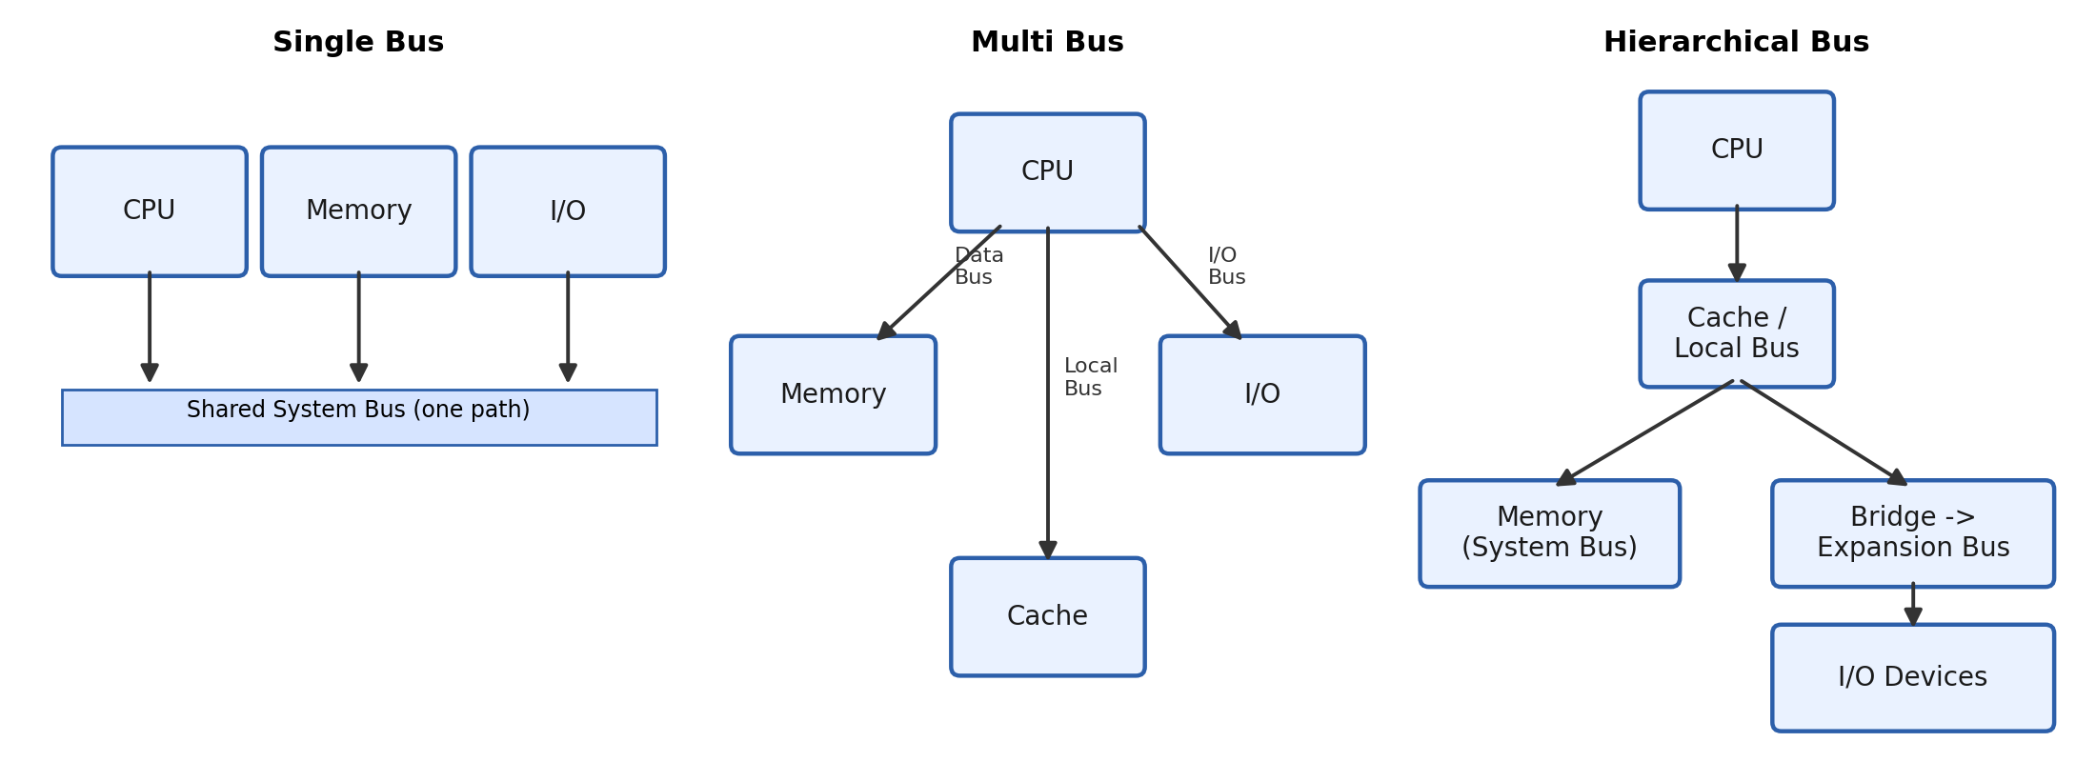
Fig 2.1 - Single Bus vs Multi Bus vs Hierarchical Bus layouts
Python Implementation
# Q2. Simple Bus Architecture Simulator
transfers = [("CPU", "Memory"), ("CPU", "IO"), ("Memory", "IO"), ("CPU", "Cache")]

def simulate(bus_type):
total_time = 0
for src, dst in transfers:
if bus_type == "single":
delay = 4 # one shared path -> full delay
elif bus_type == "multi":
delay = 4 / 3 # 3 parallel lines -> shared delay
else: # hierarchical
delay = 1.5 if src == "CPU" and dst == "Cache" else 4 # fast local path
total_time += delay
print(f"{bus_type:12} | {src:6}->{dst:6} | delay={delay:.2f} ns")

throughput = len(transfers) / total_time
print(f"{bus_type} BUS -> total time={total_time:.2f} ns, throughput={throughput:.3f} transfers/ns\n")
return throughput

results = {}
for b in ["single", "multi", "hierarchical"]:
results[b] = simulate(b)

best = max(results, key=results.get)
print(f"Best throughput -> {best} bus ({results[best]:.3f} transfers/ns)")

Sample Output
single | CPU ->Memory | delay=4.00 ns
single | CPU ->IO | delay=4.00 ns
single | Memory->IO | delay=4.00 ns
single | CPU ->Cache | delay=4.00 ns
single BUS -> total time=16.00 ns, throughput=0.250 transfers/ns

multi | CPU ->Memory | delay=1.33 ns
multi | CPU ->IO | delay=1.33 ns
multi | Memory->IO | delay=1.33 ns
multi | CPU ->Cache | delay=1.33 ns
multi BUS -> total time=5.33 ns, throughput=0.750 transfers/ns

hierarchical | CPU ->Memory | delay=4.00 ns
hierarchical | CPU ->IO | delay=4.00 ns
hierarchical | Memory->IO | delay=4.00 ns
hierarchical | CPU ->Cache | delay=1.50 ns
hierarchical BUS -> total time=13.50 ns, throughput=0.296 transfers/ns

Best throughput -> multi bus (0.750 transfers/ns)

Result
For the same workload, the Multi Bus design gave the highest throughput (0.750 transfers/ns) because transfers could happen in parallel on separate lines, the Hierarchical Bus performed better than the Single Bus because the CPU-Cache transfer used a fast local path, and the Single Bus had the lowest throughput due to full contention on one shared path. This matches the real-world trade-off: more buses reduce contention and latency but increase hardware cost.

Question 3
Create a benchmarking tool that accepts Instruction Count (IC), Clock Cycle Time, Clock Frequency, and CPI for multiple programs or processors. Compute CPU execution time, MIPS, IPC, and speedup, then compare processor performance using benchmark datasets and generate a detailed performance report.
Concept
Processor performance is commonly measured using the CPU performance equation: CPU Time = Instruction Count x CPI x Clock Cycle Time. From this, other standard metrics can be derived - Clock Frequency (1 / Clock Cycle Time), MIPS (Million Instructions Per Second), and IPC (Instructions Per Cycle, the inverse of CPI). Comparing these numbers across processors tells us which one executes a program faster, and by how much (speedup).
Approach
- Store each processor's data as (name, Instruction Count, Clock Cycle Time, CPI) in a list.
- For each processor compute Clock Frequency, CPU Time, MIPS and IPC using the standard formulas.
- Print one row per processor to build a simple comparison table.
- Find the processor with the lowest CPU time (fastest) and compute the speedup of every processor relative to it.
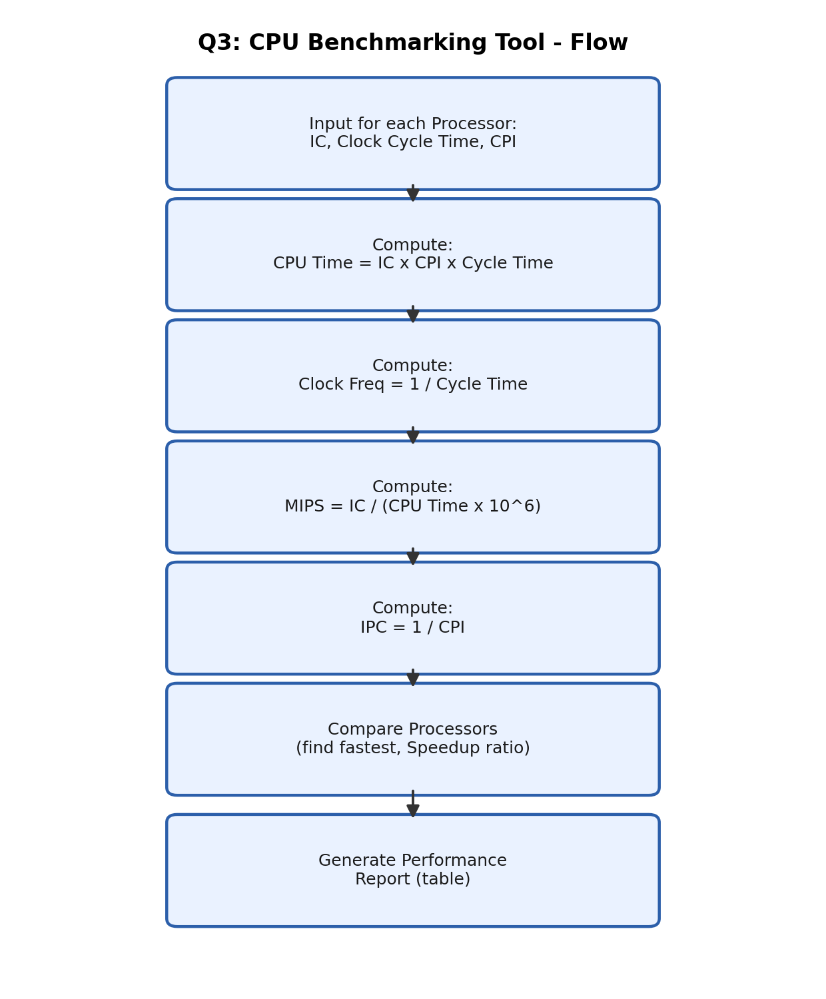

Python Implementation
# Q3. Simple CPU Benchmarking Tool
# Each processor: (name, Instruction Count, Clock Cycle Time in ns, CPI)
processors = [
("CPU-A", 50_000_000, 0.4, 1.5),
("CPU-B", 50_000_000, 0.5, 1.1),
("CPU-C", 50_000_000, 0.3, 2.0),
]

print(f"{'Name':8}{'Freq(GHz)':>12}{'CPI':>7}{'Time(us)':>12}{'MIPS':>10}{'IPC':>8}")

results = []
for name, ic, cct, cpi in processors:
freq = 1 / cct # GHz (since cct is in ns)
cpu_time = ic * cpi * cct # nanoseconds
mips = ic / (cpu_time * 1e-3) # instructions per microsecond = MIPS
ipc = 1 / cpi
results.append((name, cpu_time, mips))
print(f"{name:8}{freq:>12.2f}{cpi:>7}{cpu_time/1000:>12.1f}{mips:>10.1f}{ipc:>8.2f}")

fastest = min(results, key=lambda r: r[1])
print(f"\nFastest processor: {fastest[0]}")

for name, t, _ in results:
print(f"Speedup of {fastest[0]} vs {name} = {t / fastest[1]:.2f}x")

Sample Output
Name Freq(GHz) CPI Time(us) MIPS IPC
CPU-A 2.50 1.5 30000.0 1666.7 0.67
CPU-B 2.00 1.1 27500.0 1818.2 0.91
CPU-C 3.33 2.0 30000.0 1666.7 0.50

Fastest processor: CPU-B
Speedup of CPU-B vs CPU-A = 1.09x
Speedup of CPU-B vs CPU-B = 1.00x
Speedup of CPU-B vs CPU-C = 1.09x

Result
Even though CPU-C had the highest clock frequency (3.33 GHz), it was not the fastest overall because of its higher CPI (2.0). CPU-B, with a balanced clock speed and the lowest CPI (1.1), gave the lowest CPU execution time and hence the best performance, proving that clock frequency alone does not decide speed - CPI plays an equally important role.

Question 4
Implement a simulator for selected 8085/8086 instructions supporting immediate, direct, indirect, register, indexed, and based addressing modes. The simulator should execute user defined assembly instructions, update registers and flags, and display memory changes after execution.
Concept
Addressing mode defines how the CPU locates the operand (data) needed for an instruction. Immediate mode uses a constant written directly in the instruction. Direct mode reads a fixed memory address. Register mode uses the value already sitting in a register. Indirect mode uses a register that itself holds a memory address (a pointer). Indexed mode adds a base register and an index register to compute the effective address, and Based mode adds a base register and a fixed displacement. Real 8085/8086 instructions rely heavily on these modes to access data flexibly.
Approach
- Keep a small register dictionary and a memory list, with some starting values placed in memory.
- A single execute() function checks the addressing mode and works out the operand value for that mode (immediate value, memory address, register content, pointer, base+index, or base+displacement).
- The result is stored in the destination register and the Zero Flag is updated.
- The same function is called once for each of the six addressing modes to test all of them.

Flowchart

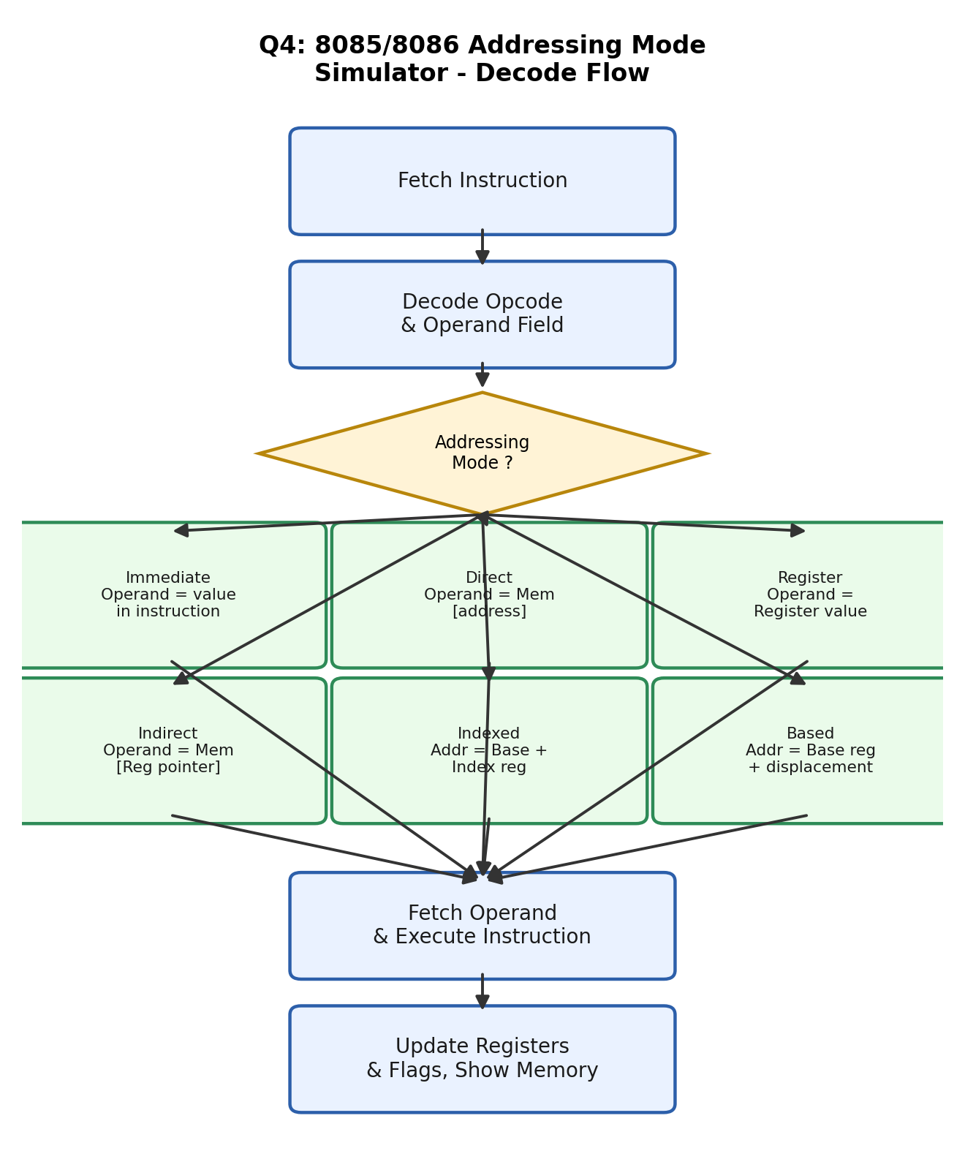

Fig 4.1 - Decode flow for the six supported addressing modes

Python Implementation
# Q4. Simple 8085/8086 Addressing Mode Simulator
reg = {"A": 0, "B": 0, "BX": 10, "SI": 2}
mem = [0] * 20
mem[10] = 55 # for direct / indirect mode
mem[12] = 77 # BX + SI -> indexed mode
mem[13] = 33 # BX + 3 -> based mode

def execute(dest, mode, value):
if mode == "immediate":
result = value
elif mode == "direct":
result = mem[value]
elif mode == "register":
result = reg[value]
elif mode == "indirect":
result = mem[reg[value]]
elif mode == "indexed":
result = mem[reg["BX"] + reg["SI"]]
elif mode == "based":
result = mem[reg["BX"] + value]

reg[dest] = result
zero_flag = 1 if result == 0 else 0
print(f"MOV {dest}, [{mode}] -> {dest} = {result} | ZF = {zero_flag}")

execute("A", "immediate", 25) # A = 25
execute("B", "direct", 10) # B = Mem[10] = 55
execute("A", "register", "B") # A = B = 55
execute("B", "indirect", "BX") # B = Mem[BX=10] = 55
execute("A", "indexed", None) # A = Mem[BX+SI] = Mem[12] = 77
execute("B", "based", 3) # B = Mem[BX+3] = Mem[13] = 33

print("\nFinal Registers:", reg)

Sample Output
MOV A, [immediate] -> A = 25 | ZF = 0
MOV B, [direct] -> B = 55 | ZF = 0
MOV A, [register] -> A = 55 | ZF = 0
MOV B, [indirect] -> B = 55 | ZF = 0
MOV A, [indexed] -> A = 77 | ZF = 0
MOV B, [based] -> B = 33 | ZF = 0

Final Registers: {'A': 77, 'B': 33, 'BX': 10, 'SI': 2}

Result
All six addressing modes - Immediate, Direct, Register, Indirect, Indexed and Based - were executed correctly, and the register/flag values updated exactly as expected after every instruction. This confirms the simulator correctly mimics how an 8085/8086 processor locates operands in memory or registers depending on the addressing mode used.

Question 5
Develop an application that converts binary, decimal, hexadecimal, and octal numbers, performs arithmetic operations in different number systems, and encodes simple assembly instructions into machine code based on predefined instruction formats and addressing modes. The program should also decode machine instructions back into assembly language.
Concept
Computers store all data in binary, but programmers commonly work with decimal, octal and hexadecimal for convenience. Converting between these bases is a core computer architecture skill. Similarly, an assembler translates human-readable assembly instructions (like MOV A, 9) into binary machine code that the CPU can execute, using a fixed instruction format (opcode + register + operand bits). A disassembler reverses this process, turning machine code back into readable assembly.
Approach
- Use Python's built-in bin(), oct() and hex() functions to show a decimal number in all number systems.
- For cross-base arithmetic, convert both operands to decimal first, add them, then display the result in all bases.
- Define a small opcode table (MOV, ADD) and a register code table, each mapped to short binary codes.
- assemble() joins opcode bits + register bits + operand bits to build the machine code.
- disassemble() reads the same bit positions back and looks them up in the tables to rebuild the original assembly instruction.

Flowchart
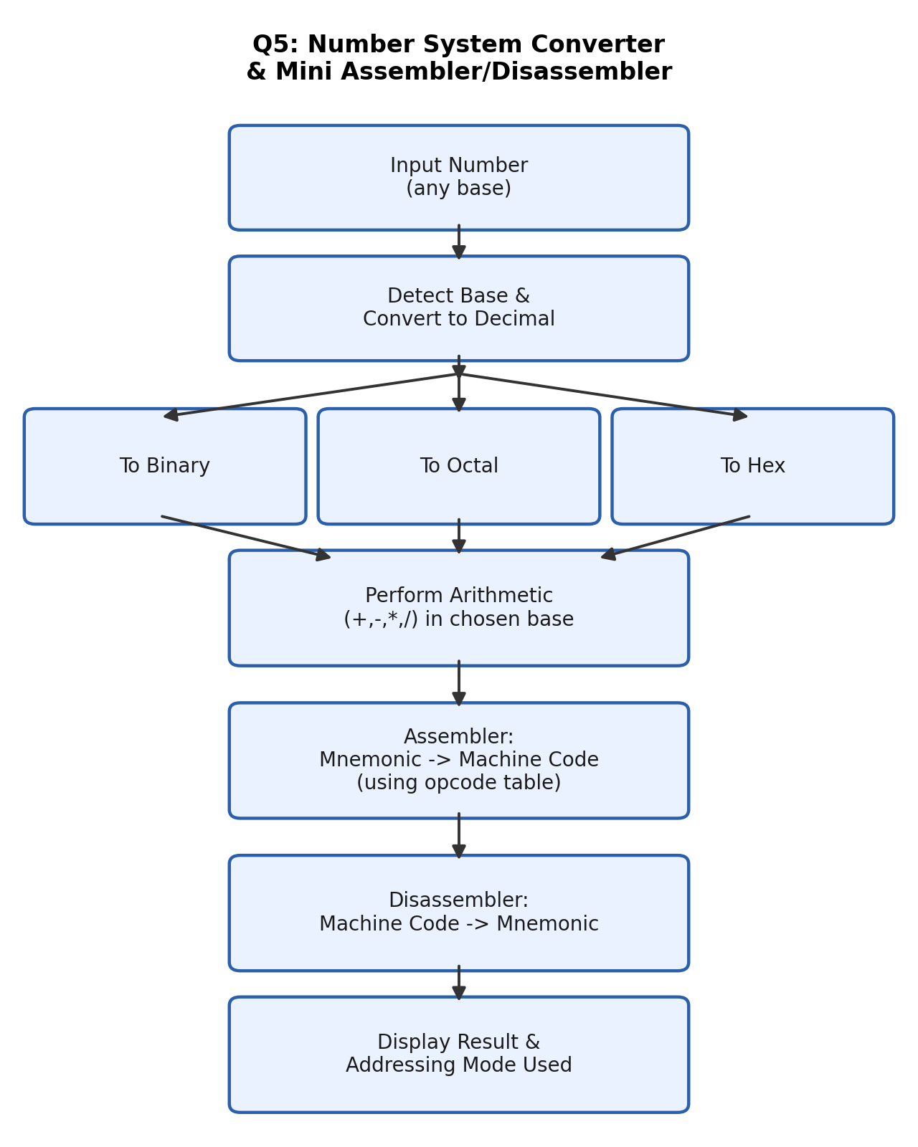
Fig 5.1 - Number conversion and assemble/disassemble flow

Python Implementation
# Q5. Number System Converter + Mini Assembler/Disassembler

def show_all_forms(n):
print(f"Decimal={n} Binary={bin(n)[2:]} Octal={oct(n)[2:]} Hex={hex(n)[2:].upper()}")

# --- Number conversion + arithmetic ---
show_all_forms(45)
a = int("1A", 16) # hex to decimal
b = int("1010", 2) # binary to decimal
show_all_forms(a + b)

# --- Mini Assembler ---
opcode = {"MOV": "01", "ADD": "10"}
regcode = {"A": "00", "B": "01"}

def assemble(instr):
op, dest, val = instr.split()
if op == "MOV":
return opcode[op] + regcode[dest] + format(int(val), "04b")
else: # ADD dest, src (register mode)
return opcode[op] + regcode[dest] + regcode[val] + "00"

def disassemble(code):
op = [k for k, v in opcode.items() if v == code[0:2]][0]
dest = [k for k, v in regcode.items() if v == code[2:4]][0]
if op == "MOV":
return f"MOV {dest} {int(code[4:8], 2)}"
src = [k for k, v in regcode.items() if v == code[4:6]][0]
return f"ADD {dest} {src}"

program = ["MOV A 9", "ADD A B"]
print()
for line in program:
code = assemble(line)
print(f"{line:10} -> {code} -> back to: {disassemble(code)}")

Sample Output
Decimal=45 Binary=101101 Octal=55 Hex=2D
Decimal=36 Binary=100100 Octal=44 Hex=24

MOV A 9 -> 01001001 -> back to: MOV A 9
ADD A B -> 10000100 -> back to: ADD A B

Result
The program correctly displayed numbers in Binary, Octal, Decimal and Hex, and correctly performed cross-base arithmetic (Hex 1A + Binary 1010 = Decimal 36). The mini assembler encoded both sample instructions into 8-bit machine code, and the disassembler decoded them back into the exact original assembly instructions, confirming the encode/decode logic works correctly in both directions.

Overall Learning Outcome (CO1)
Through these five coding challenges, the functional units of a computer system were analyzed in a hands-on manner: Question 1 covered the instruction execution cycle of the CPU, Question 2 covered bus structures used for communication between CPU, memory and I/O, Question 3 covered performance metrics such as CPI, clock cycles and benchmarking, Question 4 covered addressing modes used to access operands, and Question 5 covered number systems and instruction encoding/decoding. Together, these directly satisfy CO1: analyzing the functional units of a computer system including CPU, memory, bus structures and I/O components by examining instruction execution cycles, addressing modes, and performance metrics.
THANKYOU FOR THIS ASSESSMENT TOOL.
I CONTRIBUTED MY BEST.

